Yijun Wang

Practice 4

12/02/2021

**Part 1**

**Two-sample t-test with unequal variance:**

Using the “cats” dataset (available in R in MASS library), answer the question: do male and female cat samples have the same bodyweight (“Bwt”)? [Hint: one way to get separate vectors for male and female cat bodyweights is to use the subset function as follows: “male <- subset(cats, subset=(cats$Sex=="M"))”].

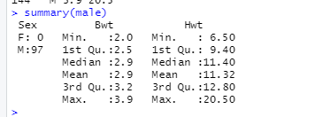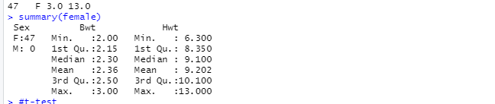

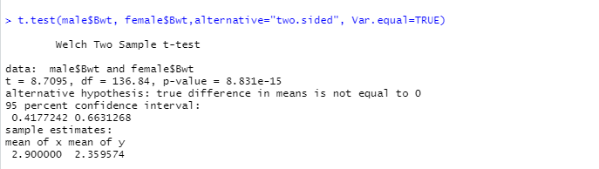

My null hypothesis is true difference in means is equal to 0, and the alternative hypothesis is not equal to 0. From t- test, I got t-value 8.7095, p value is 8.831e-15 which is less than the alpha value 0.05. So, we can reject the null hypothesis.

**Part 2.**  Use two-sample hypothesis; ask yourself whether this should be a paired T test. Does your conclusion change if the level of significance changes from 0.05 to 0.1? Lastly, justify the testing procedure you choose , why use the test of your choice rather than other tests?

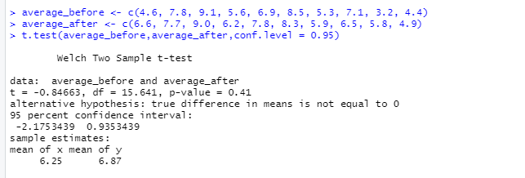

I obtained a t-value of -0.84663 and a p value of 0.41, both of which are larger than the alpha value of 0.05 from the t-test. As a result, we cannot reject the null hypothesis. Thus, 95 percent of the time, mediation has no effect on sleep quality.